Application of Thermoplastic Striping, Markings and Legends on various
City of Mobile Roadways

Project Number 2020-2060-09

Bid Date – September 16, 2020

Contents

Advertisement for Bids I
Instructions to Bidders II
Proposal III
Bid Bond IV
Labor and Materials Bond V
Performance Bond VI
Certificate of Contractor’s and Subcontractor’s Insurance VII
Special Provisions VIII
Articles of Agreement IX
Supplemental Specifications X
Location Attachment A
Contractor’s Insurance Certification Attachment B
Subcontracting and Major Supplier Plan Attachment C
E-Verify Affidavit Attachment D
Certifications, Affidavits, & Project Closeout Attachment E
Project Addendums Attachment F
Project Plan Sheets………………………………………………………………………………………………Attachment G

ITEM I
ADVERTISEMENT FOR BIDS

Notice to Contractors:

Sealed proposals will be received by the City Clerk of the City of Mobile, Alabama, 205 Government Street, 9th Floor, South Tower, until 2:30 p.m. local time, September 16, 2020 and then publicly opened and read in the Government Plaza Atrium, Ground Floor, for constructing:

Project No.: 2020-2060-09
Project: Traffic Control Striping, Markings and Legends Application
Project Description: Application of Thermoplastic Striping, Markings and Legends on various City of Mobile Roadways

Specifications and contract documents may be obtained from City of Mobile Traffic Engineering Department upon payment of twenty-five dollars ($25.00) for paper copies or may emailed to the prime Contractor Bidder by contacting the Traffic Engineering Department at trafficengineering@cityofmobile.org. This deposit shall be refunded in full to each prime Contractor Bidder upon return of the documents in reusable condition within ten (10) days after Bid Opening. The cost of and return of additional sets of specifications shall be in accordance with Act 97-225, Public Works Contracts.

No Bid Packages will be issued to Contractors later than twenty-four (24) hours after the Pre-Bid Conference. No questions, whether orally or written, will be addressed if received after 12:00 p.m. on Friday, September 11, 2020.

A Mandatory Pre-Bid Conference will be held at City of Mobile Traffic Engineering Department Conference Room, 852 Gayle Street, Mobile, Alabama on Wednesday September 9, 2020 at 2:30 p.m. Bidders that wish to attend the meeting via video conference may email the Traffic Engineering Department at trafficengineering@cityofmobile.org and request a link for the meeting. Specific items related to the proposed work will be explained. Any contractor not represented at the Pre-Bid Conference will be disqualified from bidding on the project.

No bid will be received and considered unless made out on the blank form or Proposal attached, and unless all papers attached hereto are returned with the bid and the Proposal sheet attached.

Each bid shall be accompanied by a check or bid bond for the sum of five percent (5%) of the amount bid (maximum amount of bond $50,000), made payable to the City, and certified by a reputable banking institution. These monies shall serve as assurance that within ten (10) days of notice of contract award contemplated in the Proposal, the successful bidder will enter into such contract and file a bond for the execution of same.

The performance bond required will be for the amount bid, and labor and material bond shall be one hundred percent (100%) of the amount of contract, and shall be made by a Surety Company acceptable to the City of Mobile and upon the forms of bonds appended hereto.
In default of the entering into of such contract and the execution of such bond, the certified check required to accompany such bid shall be forfeited to the City of Mobile, Alabama. These fees shall not be a penalty but damages for delays, or for the additional cost or expenses that the City may incur by reason of such default.

In addition, the Contractor must furnish to the City at the time of the signing of the Contract a certificate of insurance coverage as provided in the specification which will include comprehensive insurance, Contractor’s Automobile Liability Insurance, Owner’s Protective Liability Insurance, or a Comprehensive General and Public Liability policy naming the City of Mobile, its agents and employees as additionally insured, and where applicable, subcontractor’s Public Liability and Property Damage Insurance. The right is reserved to reject any and/or all bids and to waive informalities and to furnish any item of material or work to change the amount of said Contract.

Liquidated damages for non-completion of the work within the time limit agreed upon will be assessed according to Section 108.11 of Alabama Department of Transportation Standard Specifications for Highway Construction 2018 Edition.

Bidders must be licensed Contractors in the State of Alabama pursuant to Sections 34-8-1 through 34-8-27 of the Code of Alabama of 1975 as amended, and shall indicate State License Number on outside of bid envelope. Any contractor that desires to bid as a prime contractor must possess a Highways & Streets Specialty Construction (HS-S): Striping or Municipal and Utility Specialty (MU-S) Striping per Section 230-X-.27 of the State of Alabama Licensing Board for General Contractors Administrative Code.

The City of Mobile reserves the right to reject any and all bids and waive informalities in the bidding.

Bids must be sealed and have the project name and number marked on the outside of the envelope. The envelope containing bids must be addressed as follows, and delivered to Ms. Lisa Lambert, City Clerk; City of Mobile, P.O. Box 1827, Mobile, Alabama 36633-1827; “Bid for completion of Application of Thermoplastic Striping, Markings and Legends on various City of Mobile Roadways, City of Mobile Project No. 2020-2060-09”.

*NOTE: Due to access restrictions to Mobile Government Plaza related to COVID-19, Bid Receiving location and Pre-Bid Conference location may be adjusted. Prospective Bidders will be notified a minimum of 48 Hours prior to date and time of Receiving of Bids and 48 Hours prior to scheduled Pre Bid Conference if location(s) have been changed from those stated herein.

PLEASE PUBLISH IN THE ISSUES August 21st, August 28th, and September 4th.
ITEM II
INSTRUCTIONS TO BIDDERS

- PREPARATION OF BIDS:
Forms furnished or copies thereof shall be used and strict compliance with the requirements of the advertisement, these instructions, and the instructions printed on the forms is necessary. Special care shall be exercised in the preparation of Bids. Bidders must make their own estimates of the facilities and difficulties attending the performance of the proposed Contract, including local conditions, uncertainty of weather, and all other contingencies. All designations and prices shall be fully and clearly set forth. The proper spaces in the Bid and guaranty forms shall be suitably filled.

LABOR AND MATERIALS NOT TO BE FURNISHED BY CITY:
The City of Mobile, Alabama will not furnish any labor, materials or supplies unless specifically provided in the Contract.

SIGNATURE OF BIDDERS:
Each Bid must give the full business address of the Bidder and be signed by him with his usual signature. Bids by partnerships must furnish the full names of all partners and must be signed with the partnership name by one of the members of the partnership or by an authorized representative, followed by the signature and designation of the person signing. Bids by Corporations must be signed with the legal name of the corporation, followed by the name of State of Incorporation and by the signature of the president, secretary or other person authorized to bind it in the matter. The name of each person shall also be typed or printed below the signature. A Bid by a person who affixes to his signature the word “President”, “Secretary”, “Agent”, or other designation without disclosing his principal may be held responsible for the Bid. When requested by the City of Mobile, Alabama satisfactory evidence of the authority of the office signing on behalf of the corporation shall be furnished.

SPECIFICATIONS AND SCHEDULES:
The specifications, conditions, schedules and drawings that form the basis of any Bid will be considered as a part thereof and will form a part of the Contract. Copies of these papers, together with a copy of the standard Contract form, including authorized additions, or deletions, if any, will be furnished to or made available for the inspections of Bidders by the office indicated in the advertisement of invitation. The current specifications to be used for this project will be the Alabama Department of Transportation Standard Specifications for Highway Construction, 2018 edition, subject to any amendments set forth in the Special Provisions or the Supplemental Specifications.

CORRECTIONS:
Erasures or other changes in the Bids must be explained or noted over the signature of the Bidder.

OWNER:
Where the word “Owner” appears herein, the same refers to the City of Mobile, Alabama, and includes the Mayor acting through the City Council, its governing body.

GUARANTY AND INSURANCE:
Security is required to insure the execution of the Contract and bond for performance of the services; no Bid will be considered unless it is so guaranteed. The Bidder must furnish with his Bid, a guaranty bond or certified check in the amount of five percent (5%) (maximum amount $50,000) of his Bid price payable to the City of Mobile, Alabama. Upon default of the Contract and the execution of such bond within ten (10) consecutive working days of written notice of award of the Contract, the Certified Check or Bid Bond required to accompany such Bid shall be forfeited to the City of Mobile, Alabama, not as a penalty but as liquidated damages for delays, or any additional cost or expenses which may be incurred by the CITY by reason of such default.

BONDS AND INSURANCE:
The bonds and insurance policies of any surety company or insurance company respectively, authorized to do business in the State of Alabama, will be accepted as security and insurance as required for any Bid or Contract. See the instructions hereinafter contained and the applicable standard forms with respect to the type, form, and the amounts of required bonds and insurance policies.

MARKING AND MAILING BIDS:
Bids, with their guaranty, must be securely sealed in suitable envelopes, addressed and marked on the outside “Bid for completion of Traffic Control Striping, Markings and Legends Application, City of Mobile Project No. 2020-2060-09, in the City of Mobile, Alabama”.

TIME FOR RECEIVING BIDS:
Bids received prior to the time of opening will be securely stored, unopened. The Owner will decide when the specified time has arrived; no Bid will be considered if received thereafter. When a Bid arrives by mail after time for opening, but before award is made, and it is shown to the Owner’s satisfaction that the late arrival was due solely to mail delays, beyond the Bidder’s responsibility, the Bid will be received and considered. Non-responsibility will be attached to the City of Mobile for the premature opening of a Bid not properly addressed and identified. Unless specifically authorized, telegraphic Bids will not be considered; however, modifications to previously submitted Bids will be considered if received prior to the hour set for opening.

WITHDRAWAL OF BIDS:
Bids may be withdrawn by written or telegraphic requests received from Bidders prior to the time fixed for opening. Negligence on the part of the Bidder in preparing the Bid confers no right for the withdrawal of Bid after it has been opened.

BIDDERS PRESENT:
At the time fixed for opening Bids, Bid contents will be made public for the information of Bidders and others properly interested who may be present either in person or by representation.

AWARD OR REJECTION OF BIDS:
The Contract will be awarded to the lowest responsible Bidder, complying with the conditions of the Invitation for Bids, provided his Bid is reasonable and in the best interest of the Owner for acceptance. The Bidder to whom the award is made will be notified at the earliest possible date. The Owner, however, reserves the right to reject any and all Bids and to waive any informality in Bids received whenever such rejection or waiver is in the best interest of the Owner. The Owner also reserves the right to reject the Bidder who has previously failed to perform properly or complete projects on time; to complete Contracts of a similar nature; or a Bidder who is not, in the judgment of the Owner, in a position to perform the Contract.

PRE-QUALIFICATION OF BIDDERS:
Any contractor that desires to bid as a prime contractor must possess a Highways & Streets Specialty Construction (HS-S): Striping or Municipal and Utility Specialty (MU-S): Striping per Section 230-X-.27 of the State of Alabama Licensing Board for General Contractors Administrative Code at the time of bid opening.

ISSUANCE OF PROPOSAL FORMS:
The Owner reserves the right to refuse to issue a proposal form to a prospective bidder, should such bidder be in default for any of the following reasons:
  - Failure to comply with any pre-qualification regulations of the Owner if such regulations are cited, or otherwise included, in the proposal as a requirement for bidding.
  - Failure to pay, or satisfactorily settle, all bills due for labor and materials on former contracts in force (with the owner) at the time the owner issues the proposal to the prospective bidder.
  - Contractor default under previous contracts with the owner.
  - Unsatisfactory work of any nature, or failure to meet schedule on previous contracts with the Owner.
  - Uncompleted work or work behind schedule, which, in the opinion of the owner, might hinder or prevent prompt completion of this work.
  - Lack of competent workmen and equipment to perform at least 50% of the required work with contractor’s own forces and equipment.

BIDDERS INTERESTED IN MORE THAN ONE BID:
If more than one Bid is offered by any one party, by, or in the name of his clerk, partner, a corporation in which he has a substantial interest, in which he is an officer, or other person, all such Bids may be rejected. A party who has quoted prices on materials to a Bidder is not disqualified from quoting prices to other Bidders or from submitting a Bid directly for the materials or work. The City of Mobile reserves the right to determine, in its discretion, whether any Bidder has violated the provisions of this clause.

ERRORS IN BID:
Bidders or their authorized agents are expected to examine the maps, drawings, specifications and all other documents pertaining to the work, which will be open to their inspection. Failure to do so will be at the Bidder’s own risk; the Bidder cannot secure relief on the plea of error in the Bid. In case of error in the extenuation of prices, the unit price will govern.

Should any Bidder observe any ambiguity, discrepancy, omission, or error in the Drawings or any Contract Document, or be in doubt as to the intention and meaning thereof, he should at once report such to the City Traffic Engineer and request clarification, in writing.

Clarification will be made only by written Addenda sent to all prospective bidders. The City Traffic Engineer will not be responsible, in any manner, for verbal instructions made prior to the award of the Contract.

Should conflict occur in or between Drawings and Specifications, a Bidder will be deemed to have estimated on the more expensive way of doing the work involved; unless, prior to submission of the proposal, the bidder requested and obtained the City Traffic Engineer’s written decision indicating the preferred method, materials, or equipment.

CONTRACT AND BOND:
The Bidder to whom award is made must, when requested, enter into Contract on the standard form as set out herein, with satisfactory security in the amount required, within the period specified, within ten (10) working days after the required forms are presented to him for signature.

COLLUSION:
If there is any reason for believing that collusion exists among the Bidders, any or all Proposals may be rejected, and those participating in such collusion may be barred from submitting Bids on the same or other work with the City.

SUBLETTING OR ASSIGNING OF CONTRACT:

- Limitations: The Contractor shall not sublet, assign, transfer, convey, sell or otherwise dispose of any portion of the Contract, his right, title or interest therein, or his power to execute such Contract, to any person, firm, or corporation without written consent of the City; such consent shall not be construed to relieve the Contractor of any responsibility for the fulfillment of the Contract. Unless otherwise stipulated in the proposal or special provisions, the Contractor shall perform with his own organization, and with the assistance of workmen under his immediate supervision, and reported on his payroll, all Contract work of a value not less than fifty percent (50%) of the total Contract amount. Any items designated in the Contract as “Specialty Items”, so performed by Subcontract may be deducted from the total Contract amount before computing the amount of work required to be performed by the Contractor with his own organization.
- Subcontractor’s Status: A Subcontractor shall be recognized only in the capacity of an employee or agent of the Contractor. The Contractor will be responsible to the City for the entire Subcontractor’s work, including failures or omissions. The City Traffic Engineer may require a Subcontractor’s removal, as in the case of a Contractor’s employee.

PROSECUTION OF WORK:

  - Notice of Intent: The Contractor shall give the City Traffic Engineer definite notice of his intention to start work at least seventy-two (72) hours in advance of beginning particular features of construction, such as driving piles, placing concrete, etc. Should the Contractor, with the consent of the Engineer, discontinue prosecution of the work, the Contractor shall give the City Traffic Engineer at least forty-eight (48) hours notice in writing before resuming operations.

  - General: The Contractor shall prosecute the work continuously and diligently in the order and manner set out in his schedule as approved by the City Traffic Engineer. The Contractor shall provide sufficient material, labor, and equipment to insure that the work will be completed in a satisfactory manner within the time specified in the Contract.

Should the Contractor fail to maintain a satisfactory rate of progress, the City Traffic Engineer will direct additional forces and equipment to work on the project to ensure the project continues on schedule and maintain satisfactory progress.

Should the Contractor fail to furnish sufficient satisfactory equipment and labor for maintaining the quality and progress of the work, the City Traffic Engineer may withhold all pay requests and estimates that are or may become due, until satisfactory quality and progress are maintained or the Contract may be annulled.
ITEM III
PROPOSAL

TO: Honorable Mayor Date:
City of Mobile
Mobile, Alabama

The undersigned, as Bidder, hereby declares that he has examined the site of the work and is fully aware of conditions pertaining to the place where the work is to be done. The Bidder also declares that he has carefully examined the Instructions to Bidders, the General Conditions of the Specifications and the drawings, as prepared by the CITY TRAFFIC ENGINEER, as well as the premises

Project No.: 2020-2060-09
Project: Traffic Control Striping, Markings and Legends Application
Project Description: Application of Thermoplastic Striping, Markings and Legends on various City of Mobile Roadways

The Bidder further agrees to construct the improvements in 75 working days.

The Bidder proposes and accepts the Articles of Agreement with the City of Mobile, Mobile, Alabama to furnish all necessary materials, equipment, tools, machinery, and means of transportation, and labor to complete the construction of the project.

All work performed under this contract shall be in accordance with the State of Alabama Highway Department Standard Specifications for Highway Construction, 2018 Edition, with all latest additions and modifications by the Engineering Department for the City of Mobile, or as amended herein. The traffic stripe shall be specified as Class 2 Type AW and shall have a bead system with microcrystalline ceramic reflective optic beads. The beads shall be applied as directed by Manufacturers application guidelines.

The quantities for bid items listed on the proposal sheets are estimated quantities. Payment to the Contractor will be made only for the actual quantities of work performed and accepted on materials furnished in accordance with the contract. The scheduled quantities of work to be done and materials to be furnished may each be increased, decreased or omitted as herein provided.

No interpretations of the meaning of the plans, specifications or other bid documents will be made to any bidder orally. Any request for such interpretation should be in writing, addressed to City of Mobile Traffic Engineering Department, Attention: Jennifer White, whitej@cityofmobile.org. In order to receive consideration, the request must be received before 12:00 p.m. Friday, September 11, 2020. Any such interpretation, any supplemental instructions will be mailed or delivered to all prospective bidders.

BASE BID

Application of Thermoplastic Striping, Markings and Legends
on various City of Mobile Roadways
CITY OF MOBILE PROJECT NUMBER 2020-2016-09

Item  Number | Approx.  Quantity | Item with Unit Price Written in Words | Unit Price | Amount
600-A | 1 | Mobilization  For Dollars  And Cents  Per Lump Sum | $ | $
701-A | 67 | 5” Solid Yellow, Class 2, Type A Traffic Stripe  For Dollars  And Cents  Per Mile | $ | $
701-A | 33 | 5” Broken Yellow, Class 2, Type A Traffic Stripe  For Dollars  And Cents  Per Mile | $ | $
701-A | 80 | 5” Solid White, Class 2, Type A Traffic Stripe  For Dollars  And Cents  Per Mile | $ | $
701-A | 37 | 5” Broken White, Class 2, Type A Traffic Stripe  For Dollars  And Cents  Per Mile | $ | $
703-A | 68000 | Traffic Control Markings, Class 2, Type A  For Dollars  And Cents  Per Square Foot | $ | $
703-B | 4000 | Traffic Control Legends, Class 2, Type A  For Dollars  And Cents  Per Square Foot | $ | $
701-B | 5250 | Dotted, Class 2, Type A  For Dollars  And Cents  Per foot | $ | $
701-H | 500 | Traffic Stripe Removed  For Dollars  And Cents  Per Foot | $ | $
TOTAL BID

Base Bid

Total (All items listed in Proposal) $

Written in words:

Number of working days to complete: 75

Signature of Bidder
(If a firm or individual)

Address of Bidder

By

Signature of Bidder
(If a Corporation)

Business
By ______________________________ Address__________________________
President

Business
________________________________ Address __________________________
Secretary

Business
________________________________ Address___________________________
Treasurer

(Corporate Seal) Name of State under the Laws of which
the Corporation was chartered:

ATTEST:
Secretary State License Number

ITEM IV

BID BOND

KNOW ALL MEN BY THESE PRESENT:

That
(Name of Contractor)

(Address)
as Principal, and
(Name of Surety)

(Address)

as Surety, are held firmly bound unto the City of Mobile, a Political Subdivision of and Body Corporate in the State of Alabama as Obligee, in the full and just sum of five percent (5%) of amount bid (maximum amount of Bond is $50,000) lawful money of the United States, for the payment of which sum, well and truly to be make, we bind ourselves, our heirs, executors, administrators, successors and assigns, jointly and severally, firmly by these presents.

WHEREAS, the said principal is herewith submitting its proposal for Application of Thermoplastic Striping, Markings and Legends on various City of Mobile Roadways, City of Mobile Project Number 2020- 2060-09.

The condition of this obligation is such that if the aforesaid Principal shall be awarded the contract the said Principal will, within the time required, enter into a formal contract and give a good and sufficient bond to secure the performance of the terms of and conditions of the Contract, then this obligation is to be void; otherwise, the Principal and the Surety will pay unto the Obligee the difference in money between the amount of the Contract as awarded and the amount of the proposal of the next lowest bidder, which amount shall not exceed $10,000. If no other bids are received, the full amount of the proposal guarantee shall be so retained or recovered as liquidated damages for such default.

Signed, Sealed and Delivered (Date)

(Contracting Firm)

Witness as to Principal by: (SEAL)

(Name of Surety)

COUNTERSIGNED:

Alabama Resident Agent By

BIDS WILL NOT BE CONSIDERED UNLESS BID BOND IS SIGNED BY PRINCIPAL AND SURETY.

ITEM V

LABOR AND MATERIALS BOND

KNOW ALL MEN BY THESE PRESENT, that we
____________________ as Principal and
as Surety, are held and firmly bound unto said City of Mobile, a political subdivision of the body corporate in the State of Alabama, hereinafter called the Obligee, in the penal sum of
_________________________________________________________________________________
Dollars ($_______________________) lawful money of the United States, for the payment of which
sum and truly to be made, we bind ourselves, our heirs, personal representatives, successors and assigns, jointly and severally, firmly by these presents.

WHEREAS, said Principal has entered into a certain Contract with said Obligee, dated _____________________, 20___ (hereinafter called the Contract) for Application of Thermoplastic Striping, Markings and Legends on various City of Mobile Roadways, City of Mobile Project Number 2020- 2060-09 which Contract the Specifications for said work shall be deemed a part hereof as fully as if set out herein.

NOW, THEREFORE, THE CONDITION OF THIS OBLIGATION IS SUCH THAT if said Principal, all subcontractors to whom any portion of the work in said Contract is sublet, all assignees of said Principal and of such subcontractors shall promptly make payments to all persons supplying him or them with labor, materials, or supplies for or in the prosecution of the work provided for in such Contract, or in any amendment or extension of or addition to said Contract, and for the payment of reasonable attorney's fees, incurred by the successful claimant or plaintiffs in suits or claims against the CONTRACTOR arising out of or in connection with the said Contract, then the above obligation shall be void; otherwise to remain in full force and effect.

PROVIDED, however, that this bond is subject to the following conditions and limitations:
- Any person, firm or corporation that has furnished labor, materials, or supplies for or in the projection of the work provided for in said Contract shall have a direct right of action against the Principal and Surety on this bond, which right of action shall be asserted in a proceeding, instituted in the CITY, in which the work provided for in said Contract is to be performed or in any CITY in which said Principal or Surety does business. Such right of action shall be asserted in a proceeding instituted in the name of the claimant or claimants for his or their use and benefit against the Principal and Surety or either of them (but not later than one year after the final settlement of said Contract falls due) in which action such claim or claims shall be adjusted and judgment rendered thereon.

- The Principal and Surety hereby designate and appoint the Mayor of the City of Mobile, Mobile County, State of Alabama, or his successor or representative, as the agent of each of them to receive and accept services of process or other pleading issued or filed in any proceeding instituted on this bond and hereby consent that such service shall be the same as personal service on the Principal and/or Surety.
- The Surety shall not be liable hereunder for any damage or compensation recoverable under Workmen's Compensation or Employer's Liability Statute.

- In no event shall the Surety be liable for a greater sum than the penalty of this bond, or subject to any suit, action or proceeding thereon that is instituted later than one year after the final settlement of said contract.

- This Bond is given pursuant to the terms of an Act of the Legislature of the State of Alabama approved February 8, 1935, entitled: "An Act to Further Provide for Bonds of Contractors on State and Other Public Works and Suits Thereon."

SIGNED, SEALED AND DELIVERED this __________ day of ___________________, 20______.

Individual Principals sign here

____________________________(SEAL)

____________________________(SEAL)

In the presence of: ____________________________(SEAL)

___________________________

___________________________ (Corporate Name)

BY:__________________________
(Signature)

ITS:__________________________
(Title)
ATTEST:
___________________________
(Signature)

ITS:_______________________ (Surety sign here)(Corporate name)

BY:___________________________
(Signature)

ITS:__________________________
ATTEST: (Title)
___________________________
(Signature) Corporate Seal

ITS:_______________________
(Title)

ITEM VI

PERFORMANCE BOND

KNOW ALL MEN, that we
(Name of Contractor)
a Corporation , Partnership , or Individual (underline correct legal title of Contractor), hereinafter called the “Principal”, and

(Name and Address or legal title of one or more sureties)
hereinafter called the “Surety”or“Sureties”,are held and firmly bound unto the Council of the City
of Mobile, Alabama hereinafter called the “Owner”, the sum of______________________________
______________________________________________Dollars ($__________________________),
for the payment whereof the Principal and the Surety or Sureties bond themselves, their heirs, executors, administrators, successors and assigns, jointly and severally, firmly by these presents.

WHEREAS, the Principal has, by means a written agreement with said Obligee, dated _____________________, 20___ , entered into a Contract with the Owner for Application of Thermoplastic Striping, Markings and Legends on various City of Mobile Roadways, City of Mobile Project Number 2020- 2060-09 which agreement is by reference made a part hereof.

NOW THEREFORE, the condition of this obligation is such that if the Principal shall faithfully perform the Contract on his part, and satisfy all claims and demands, incurred for the same, and shall fully indemnify and save harmless the Owner from all cost and damage which he may suffer by reason of failure to do so, and shall fully reimburse and repay the Owner all outlay and expense which the Owner may incur in making good any such default, thence this obligation shall be null and void; otherwise it shall remain in full force and effect.

PROVIDED, however, that no suit action or proceedings by reason of any default whatever be brought on his Bond after twelve months from the day on which the final payment under the Contract falls due.

PROVIDED, further that the said Surety, or Sureties, for the value received hereby stipulate and agree that no charge, extension of time or addition to the terms of the Contract or to the work to be performed thereunder of the Specifications thereof shall in any way effect their obligations on this bond, and they do hereby waive notice of such change, extension of time, alteration or addition to the terms of the contract, or to the work, or to the Specifications.
SIGNED, SEALED AND DELIVERED this __________ day of ___________________, 20______.

Individual Principals sign here

____________________________(SEAL)

____________________________(SEAL)

____________________________(SEAL)
In the presence of:

___________________________

___________________________
(Corporate Name)

BY:__________________________
(Signature)

ITS:__________________________
(Title)
ATTEST:

___________________________
(Signature)

ITS:_______________________
(Surety sign here)(Corporate name)

BY:___________________________
(Signature)

ITS:__________________________
(Title)
ATTEST:

___________________________ Corporate Seal
(Signature)

ITS:_______________________
(Title)

During the performance of this contract, the CONTRACTOR agrees as follows:

- The CONTRACTOR will not discriminate against any employee or applicant for employment because of race, creed, color, or national origin. The CONTRACTOR will take affirmative action to insure that applicants are employed, and that employees are treated during employment, without regard to their race, creed, color or national origin. Such shall include but not be limited to the following:

Employment, upgrading, demotion or transfer; recruitment or recruitment advertising; layoff or termination; rates of pay or other forms of compensation, and selection for training, include apprenticeship. The CONTRACTOR agrees to post in conspicuous places, available to employees and applicants for employment, notices to be provided by the contracting agency of the municipality setting forth the provisions of this nondiscrimination clause.

- The CONTRACTOR will, in all solicitations or advertisements for employees placed by or on behalf of the CONTRACTOR, state that all qualifying applicants will receive consideration for employment without regard to race, creed, color, or national origin.

- The CONTRACTOR will send to each labor union or representative of workers with which he has a collective bargaining agreement or other Contract or understanding, a notice to be provided by the municipal contracting agency, advising the labor union or workers’ representative of the CONTRACTOR’s commitments under this ordinance. Copies of the notice shall be posted in conspicuous places available to employees and applicants for employment.

- In the event of the CONTRACTOR’s non-compliance with the non-discrimination clauses of this Contract, this Contract may be canceled, terminated or suspended in whole or in part and the CONTRACTOR may be declared ineligible for further municipal contracts.

- CONTRACTOR will include the provisions of this ordinance in every subcontract or purchase order unless exempted by written orders of the governing body of the City of Mobile so that provisions will be binding upon each subcontractor or vendor.
ITEM VII
INSURANCE

Insurance: CONTRACTOR shall take out and maintain during the life of the contract the following:

Contractor shall name the City of Mobile as an additional insured.

- Workers' Compensation/Employer's Liability:

  - Workers' Compensation insurance in the amounts required by all applicable laws, rules or regulations of the state of Alabama.

  - Employer's Liability with limits of not less than:
Bodily Injury by Accident $1,000,000 each accident
Bodily Injury by Disease $1,000,000 policy limit
Bodily Injury by Disease $1,000,000 each employee

  - Borrowed Servant/Alternate Employer endorsement in favor of City of Mobile.

- Comprehensive General Liability Insurance:

  - Comprehensive General Liability (occurrence form) including coverage for products/completed operations, independent contractors, blanket contractual liability specifically covering the obligations assumed by Contractor.

  - Limit of Liability: $1,000,000 combined single limit of liability each occurrence bodily injury or property damage.

  - General Aggregate Limit shall apply on a "Per Project" Basis.

- Automobile Liability Insurance:

  - Automobile Liability Insurance to cover any auto, including all owned , non-owned, and hired vehicles, with a $1,000,00 0 combined single limit of liability each accident for bodily injury and/or property damage.

- Excess/Umbrella Liability Insurance

  - Providing following form coverage for Employer's Liability, Comprehensive General Liability, and Automobile Liability.

  - Limit of Liability: $2,000,000 combined single limit of liability each occurrence for bodily injury and/or property damage.
- CERITIFICATE OF LIABILITY INSURANCE ENDORSEMENT PAGE

The policy endorsements listed below are required and must be listed in the "Descriptions of Operations" box on the Certificate of Liability Insurance or listed separately on an attachment to the certificate of insurance (ACORD 101, Additional Remarks Schedule) .

- Waiver of Subrogation - All policies of insurance shall be endorsed to waive rights of subrogation in favor of City of Mobile.

- Additional Insured - All policies of insurance, except those referenced under paragraph A, shall be endorsed to name City of Mobile as an Additional Insured

- Primary Insurance - All policies of insurance, except those referenced under paragraph A, shall be endorsed to provide that all such insurances are primary and non-contributing with any other insurance maintained by City of Mobile.

- Notice of Cancellation - Certificates of Insurance shall provide that such insurance shall not be subject to cancellation, non-renewal nor material change without 30 days or more (except 10 days for non-payment) prior written notice thereof to the City of Mobile.

- Certificates of Insurance - General - Within ten (10) calendar days from the date of issuance of Contract forms for execution, Contractor shall deliver to the City of Mobile, certificates of insurance (standard ACORD format) certifying the existence and limits of the insurance coverages along with separate policy endorsements as described above. Contractor shall also be responsible for delivering policy renewal certificates to the City of Mobile. A sample Certificate of Liability Insurance form, including the policy endorsement requirements is attached for Contractor's reference.

ITEM VIII

SPECIAL PROVISIONS

- Subletting or Assigning of Contract:
  - Limitations: The Contractor shall not sublet, assign, transfer, convey, sell or otherwise dispose of any portion of the contract, his right, title or interest therein, or his power to execute such contract, to any person, firm or corporation without written consent of the City and such written consent shall not be construed to relieve the Contractor of any responsibility for the fulfillment of the contract. Unless otherwise stipulated in the proposal or special provisions, the Contractor shall perform with his own organization, and with the assistance of workmen under his immediate supervision and reported on his payroll, all contract work of a value not less than 50 percent of the total contract amount, except that any items designated in the contract as "Specialty Items" may be performed by subcontract, and the cost of any such "Specialty Items" so performed by subcontract may be deducted from the total contract amount before computing the amount of work required to be performed by the Contractor, with his own organization.

  - Subcontractor's Status: A subcontractor shall be recognized only in the capacity of an employee or agent of the Contractor and the Contractor will be responsible to the City for all subcontractors’ work, including failures or omissions; and his removal may be required by the City Traffic Engineer, as in the case of an employee.

- The contractor shall not sublet the contract or any portion thereof without written permission from the City Traffic Engineer. If consent is given, the contractor will be permitted to sublet a portion of the work, but shall perform with his own organization, work amounting to not less than fifty (50%) percent of the total contract price. The performance of the contract may not be assigned.

- The City Traffic Engineering Department reserves the right to disqualify or refuse to award the contract to a prospective bidder for the following reasons:
  - Uncompleted work which, in the judgment of the City Traffic Engineering Department, might hinder or prevent the prompt completion of additional work if awarded.

  - Failure to pay or satisfactorily settle all bills due to labor and material on former contracts in force at the time of issuance of proposals.

  - Default, as defined in Article 108.12 of the Alabama Department of Transportation Standard Specifications for Highway Construction, 2018 Edition, with all latest additions and modifications of the Engineering Department for the City of Mobile under a previous contract, or unsatisfactory work of any nature on previous work. In addition to the above, disqualification for unsatisfactory progress of an on-going contract will be administered as outlined in Sub article 108.04(c) Alabama Department of Transportation Standard Specifications for Highway Construction, 2018 Edition, with all latest additions and modifications of the Engineering Department for the City of Mobile. Disqualification applies to bidding as a prime contractor or doing any subcontract work for a prime contractor.

  - The Owner, reserves the right to reject any Bidder who has previously failed to perform properly or complete on time contracts of similar nature, or a bid of a bidder who is not, in the judgment of the Owner, in a position to perform the Contract.

- The successful bidder shall make every reasonable effort to have at least fifteen (15%) percent of the total value of the contract performed by socially and economically disadvantaged individuals. A City of Mobile DBE Compliance Form must be submitted with the bid documents.

- It is the intent to construct the within described work as shown on the plans and specifications prepared by the City Traffic Engineering Department of the City of Mobile in accordance with the Alabama Department of Transportation Standard Specifications for Highway Construction, 2018 Edition, with all latest additions and modifications of the Engineering Department for the City of Mobile.

- In said specifications, where the words “State of Alabama”, “Governor”, “State”, “State Highway Department”, “Director”, etc. appear substitute “City of Mobile Traffic Engineering Director, acting by and through its Mayor”.

- All insurance and bonds must be furnished by a Surety licensed to do business in the State of Alabama, signed or countersigned by a licensed Resident Agent of Alabama and have a minimum rating of A Class VI as reported in the latest issue of Best's Key Rating Guide Property and Casualty.

- Payment for any work incidental to the completion of this contract, for which no item was set up, shall be absorbed in other bid items.

- The City of Mobile reserves the right to add to or reduce quantities or delete any item or items in this contract without any adjustment in unit price. Additional items of work necessary for the completion of this contract may be added by Change Order.

- Failure to complete the work in this contract within the time stipulated will result in a deduction for money due the contractor. Such liquidated damages will be assessed as provided for in Item 108 of the Alabama Department of Transportation Standard Specifications for Highway Construction, 2018 Edition, with all latest additions and modifications of the Engineering Department for the City of Mobile.

The contractor shall provide maintenance for a period of one year from final acceptance of the work. This maintenance work shall include furnishing all materials, labor, and incidentals necessary to maintain the project in acceptable condition as determined by the City Traffic Engineering Department. This maintenance for a one year period shall be provided with no additional compensation.

- The City of Mobile may retain a reputable laboratory to make all tests, inspections, etc. required by the Alabama Department of Transportation Standard Specifications for Highway Construction, 2018 Edition, with all latest additions and modifications of the Engineering Department for the City of Mobile at no cost to the contractor. The laboratory shall furnish copies of all test results to the City Traffic Engineer.

- The Contractor shall have on the job site at all times, as his agent, a competent superintendent capable of reading and thoroughly understanding the plans and specifications and thoroughly experienced in the type of work being performed, who shall receive instructions from the City Traffic Engineer or his authorized representatives. The Superintendent shall have full authority to execute orders or directions of the City Traffic Engineer without delay and to promptly supply such materials, equipment, tools, labor and incidentals as may be required. Joint venture Contractors shall have one such superintendent for all ventures. Such superintendents shall be furnished irrespective of the amount of work sublet and shall have full authority over all subcontract work. The superintendent shall be required to have direct communication with the supplier in case of mechanical failure at the site or the plant.

- The contractor shall take all necessary precautions for the protection of the work and safety and comfort of the general work. Such work shall comply with applicable spec sections of Items 104 and 107. There will be no compensation for this work.

- The quantities shown on the proposal and plans are approximate. The Contractor will be paid only for the amount of each item to complete the project.

- It shall be the Contractor’s responsibility to determine if the required construction can be performed within the area provided and comply with requirements of the Occupational Safety and Health Regulations (OSHA) for construction projects of this type. Any safety measures or methods of construction that are necessary in the construction of this project to comply with these regulations are the Contractor’s responsibility and shall be provided with all costs to be included in the various pay items of the contract (no direct payment).

- The Contractor shall submit a Traffic Control Scheme for the City Traffic Engineer’s approval prior to commencement of any work on this project. The scheme shall be in full compliance with all the provisions and requirements as designated in Item 740 and Article 104.04 of the Standard Specifications, the Manual on Uniform Traffic Control Devices, 2018 Edition, and other requirements set forth by the City Traffic Engineer. There shall be no direct payment for said traffic control plan preparation or for items in Section 740. All materials, signage, lights, hardware, drums, equipment, labor, handling and maintenance until project completion and any other incidentals necessary to complete the job shall be considered incidental to the project. The Contractor shall restore existing traffic mechanisms to original condition.

- All equipment shall be in good mechanical working order. If not, the Project Inspector can require removal from the project.

- Any damage caused by the Contractor or his subcontractors to the existing bituminous asphalt surface and/or base structure on local streets leading to or associated with this project shall be repaired by the Contractor at no cost to the owner.

- Contactor shall remove and dispose of all waste and unsuitable material, from the project site. The Contractor will be held responsible for disposal of debris and construction materials in an appropriate manner and at an approved, permitted location. The Contractor will be responsible for compliance with applicable laws or ordinances regarding material type and disposal site. Disposal of construction materials and debris is specified in Sub articles 206.4(c) and 201.03(d) of the Standard Specifications.

- The contractor shall take whatever steps are necessary to insure that dust is controlled during operations.

- It is the sole responsibility of the Contractor to protect his/her equipment. The City shall not entertain any claims by the Contractor due to any damage to his or her equipment or materials.

- The Contractor shall use extreme caution when working in close proximity to existing houses or other structures. Any damage to the existing structures from the Contractor’s negligence shall be repaired at the Contractor’s expense. The Contractor shall be very cautious of existing landscaping items located within the project area. Any damage to existing items not scheduled to be removed shall be replaced at the Contractor’s expense.

- The contractor shall be responsible for implementing and maintaining any and all necessary environmental control measures in accordance with all Local, State, and Federal laws and requirements. This includes protection from concrete surface preparations, erosion and sediment controls, as well as a result from any other construction related activities. There will be no direct payment for the materials, equipment, labor or other incidentals required to fulfill this requirement, shall be subsidiary of Item No. 600A, Mobilization.

- The Contractor shall be responsible for implementing all erosion control BMPs on City construction projects and for all sediment within and leaving the construction site until the project is accepted by the City. Severe penalties will be imposed to ensure compliance.

- All projects and construction sites shall be in accordance with the Clean Water Act; the Alabama Water Pollution Control Act; the current version of the Alabama Handbook for Erosion Control, Sediment Control and Stormwater Management on Construction Sites and Urban Areas; current version of the Mobile, Alabama City Code Chapter 17 Stormwater Management and Flood Control. Any fines, penalties, or judgments accessed to City of Mobile, its agents or representatives due to inadequately installed or maintained erosion control shall be the responsibility of the Contractor. The Contractor shall indemnify and hold harmless the City of Mobile or its agents from all claims resulting, all or in part, from inadequately installed or maintained erosion control.

- Working hours on certain streets will be limited. All working times, closures, etc., will be coordinated with the City of Mobile Traffic Engineering Department. Based on specific locations, work at night or weekends may be necessary.

- Attention is drawn to the fact that this work will be performed under traffic conditions requiring special care to expedite the work and prevent undue hazardous conditions. Traffic control will be the responsibility of the Contractor in accordance with the Manual on Uniform Traffic Control Devices (MUTCD). Specific areas will require different levels of traffic control as indicated in the MUTCD. All Contractor employees who are exposed to the risks of moving roadway traffic or construction equipment must wear high-visibility apparel meeting the standards of ANSI 107-2004 Class 3. The City Traffic Engineer or his designee shall have the right to suspend work performance of a Contractor found to be in non-compliance on a particular worksite.

- All workmanship shall be of a professional quality and standard as generally accepted in the trade. All workmanship is subject to inspection and approval by the City Traffic Engineer, or his designee.

- All traffic control configurations shall be restored to their original patterns, unless otherwise directed by the City Traffic Engineer.

- The Contractor will be responsible for contacting the City Traffic Engineer or his designee daily to discuss the proposed work schedule for the day. This should be done at either the beginning of the day or end of the day to cover the previous day’s work or the next day’s work schedule. Projections for the following week should be communicated by Thursday of the preceding week. If no work is anticipated for a one week period, the Contractor must notify the City Traffic Engineer or his designee by Tuesday morning of said week. Telephone or email communication is acceptable for notifications.
ITEM IX
ARTICLES OF AGREEMENT

STATE OF ALABAMA
COUNTY OF MOBILE
CITY OF MOBILE)

(Executed in Quintuplicate)

- THIS AGREEMENT made and concluded this _________ day of __________________, 20___, by and between the CITY OF MOBILE, ALABAMA, by its Mayor duly authorized party of the first part, and _ , party of the second part.

WITNESSETH: That the said party of the second part has agreed and by these present does agree with the said party of the first part, for the consideration hereinafter mentioned and contained, and under the penalty expressed in a bond bearing even date with these presents and hereunto annexed, to furnish at their/his own proper cost and expense, all the necessary materials, equipment and labor, of every description and to carry out and complete in a good, firm and substantial manner the following:

Project Name: Traffic Control Striping, Markings and Legends Application
Project No: 2020-2060-09
Project Description: Application of Thermoplastic Striping, Markings and Legends on various City of Mobile Roadways

City of Mobile Project Number 2020-2060-09, all complete in place with all appurtenances for the consideration of unit prices set forth in CONTRACTOR’s Proposal (estimated to total $ ) in strict accordance with this contract. The advertisement, proposal, special provisions, plans and specifications are all made a part of this agreement.

CITY:
- Wherever the word “CITY” is used, it shall refer to the City of Mobile, Alabama.

COUNCIL:
- Whenever the word "COUNCIL" is used in the Specifications, it shall refer to the governing body of the City of Mobile, Alabama, the party of the first part of the Agreement.

CONTRACT:
- Whenever the word "CONTRACT" is used it shall be held to mean the executed documents comprising the written agreement between the City of Mobile and the Contractor setting forth the obligations of the parties hereunder for the performance of the prescribed work. The Contract includes the invitation for bids, proposal, contract forms and contract bonds, specifications, supplemental specifications, special provisions, general and detailed plans, these Articles of Agreement, notice to proceed, and any change orders that are required to complete the construction of the work in an acceptable manner, including authorized extensions thereof, and such other documents as by law or references are made a part thereof, all of which constitute one instrument.

CONTRACTOR:
- Whenever the word "CONTRACTOR" is used it shall be held to mean any individual, corporation, partnership, or other entity selected to perform any or all construction services. The contractor shall be eligible to bid Alabama Department of Transportation projects at the time of the bid opening to be considered a valid bidder for this project.

CITY TRAFFIC ENGINEER:
- Whenever the word "CITY TRAFFIC ENGINEER" is used, it shall refer to the TRAFFIC ENGINEERING DIRECTOR for the City of Mobile or his appointed assistant.

AUTHORITY OF THE CITY TRAFFIC ENGINEER:
- The CITY TRAFFIC ENGINEER will decide all questions which may arise as to the quality and acceptability of materials furnished and work performed and as to the rate of progress of the work; all questions which may arise as to the interpretation of the plans and specifications; all questions as to the acceptable fulfillment of the contract on the part of the CONTRACTOR.

The CITY TRAFFIC ENGINEER shall have the authority to withhold further payment or to suspend the work wholly or in part due to failure of the CONTRACTOR to correct conditions unsafe for the workmen or the general public; failure to carry out provisions of the contract; failure to carry out orders; for such periods as he may deem necessary due to unsuitable weather; for conditions unsuitable for prosecution of the work; or for any other conditions or reason deemed to be in the public interest.

DUTIES OF THE CONTRACTOR:
- The work performed under this contract and agreement shall be in strict compliance with the "State of Alabama Highway Department Standard Specifications for Highway Construction”, 2018 Edition, with all latest additions and modifications by the Engineering Department of the City of Mobile and with the plans on file in the office of the CITY TRAFFIC ENGINEER or as noted herein.

ARBITRATOR:
- Both parties to this contract hereby agree that the CITY TRAFFIC ENGINEER shall act as referee in all questions and disputes arising under the terms of this Contract between the parties thereto and that the decision of the CITY TRAFFIC ENGINEER in all such cases shall be final.

STANDARD SPECIFICATIONS:

Whenever the word "STANDARD SPECIFICATIONS" is used, it shall refer to State of Alabama Department of Transportation Standard Specifications for Highway Construction, 2018 edition, with all latest additions and modifications by the Engineering Department of the City of Mobile, a copy of which is on file in the office of the CITY ENGINEER.

WAGE SCALE:
- The CONTRACTOR will be required to pay the prevailing wage rates for this district that are applicable to the trades engaged in the several different lines of work.

APPOINTMENT AND AUTHORITY OF INSPECTORS:
- The CITY TRAFFIC ENGINEER may appoint such inspectors, assistants, or representatives as he deems necessary, and they shall be granted full access to the work and to the mills and factories in which material is being prepared for use under the contract.

Inspectors will be authorized to inspect all work done and materials furnished. Such inspection may extend to all or any part of the work and to the preparation, fabrication or manufacture of the materials to be used. The inspector will not be authorized to alter or waive the provisions of this contract. The inspector will not be authorized to issue instructions contrary to the plans and specifications, or to act as foreman for the CONTRACTOR; however, he shall have the authority to reject work or materials until any questions at issue can be referred to and decided by the CITY TRAFFIC ENGINEER.

The CITY TRAFFIC ENGINEER reserves the right to require replacement of any inspector considered to be unqualified for the work.

INSPECTION:
- Inspection and acceptance of materials and construction during the progress of the work shall not relieve the CONTRACTOR from any of the obligations assumed under this contract to furnish materials and to perform work strictly in accordance with its terms, and any work in accordance therewith (although overlooked and passed), shall be made good and inferior materials shall be removed and replaced with proper materials upon the demand of the CITY Traffic ENGINEER at any time prior to the completion of the work and its acceptance by the CITY TRAFFIC ENGINEER.

INCOMPETENT EMPLOYEES TO BE DISCHARGED:
- If the work of any person employed by the CONTRACTOR should appear to the CITY TRAFFIC ENGINEER to be incompetent or disorderly, he shall be immediately discharged upon the request of the CITY TRAFFIC ENGINEER.

CHANGES AND EXTRA WORK:
- Should the COUNCIL deem it proper or necessary in the execution of the work to make any alterations, which shall increase or diminish the quantities or the expense, such alterations or reductions shall not validate or annul the contract or agreement hereby entered into. The said COUNCIL shall determine the value of the work to be added or omitted; such value to be added to or to be deducted from the contract price as the case may be.

No claim whatever shall be made by the CONTRACTOR for extra materials or work, or for a greater amount of money than is herein stipulated to be paid, unless some changes in or additions to said work requiring additional outlay by the CONTRACTOR shall first have been ordered, in writing, by the said COUNCIL on application of the CITY TRAFFIC ENGINEER. Said writing will be attached to the contract for the making of said improvements, stating that such work is not included in the contract, what the extras are and that such are necessary for the proper completion of the work, or for the security of the work previously done and the reason therefor.

RESPONSIBILITY FOR ACCIDENTS:
- The CONTRACTOR covenants to and shall defend, hold harmless, indemnify and exonerate the CITY and any of its officers, directors and employees of and from any and all claims, demands, liability, losses, damages, suits and/or judgments, whether frivolous or otherwise of any character, arising out of, or connected with, the work covered by this contract, regardless of how it may be caused. The CONTRACTOR shall be responsible for providing the City of Mobile and any of its officers, directors, and employees a defense and paying all costs of defending it and investigating said claims, including attorney’s fees and expenses.

WORK TO BE PROSECUTED AS DIRECTED:
- All work shall be done according to the direction of the CITY TRAFFIC ENGINEER or his authorized assistant.

GENERAL COMPLIANCE WITH LAWS:
- The Contractor shall comply with the provisions of the labor laws, state laws and federal and local statutes, ordinances and regulations that are applicable to the performance of this Agreement, and procure all necessary licenses and permits.

SUSPENSION OF WORK:
- If, in the opinion of the CITY TRAFFIC ENGINEER, during the progress of the work the conditions of the weather make it inexpedient or hazardous to proceed with the same, or if the public need seems to demand a temporary suspension, prosecution of the project shall cease for such a period as the CITY TRAFFIC ENGINEER may direct in writing. No allowance will be made to the CONTRACTOR for damages alleged to have been sustained on account of such suspension of the work. The period of such cessation shall be determined and recorded by the CITY TRAFFIC ENGINEER and shall be added to the time herein specified for the completion of the work. It is further agreed that in case of any legal obstruction or injunction affecting the prosecution of the work, such delay shall extend the time of completion of such part or parts of the work as obstructed and delayed for the length of time the obstruction continued and no longer. No damages shall be claimed or allowed the CONTRACTOR by reason of such unavoidable delay.

DELAYS:
- Delay in completion or the acceptance of any portion of the work shall not be deemed or construed as a waiver of any of the rights of the CITY under this contract, or to prevent the abrogation of this contract on account of the violations of its terms or the enforcement and collection of any just claim for loss or damage sustained by the CITY by reason thereof. Should delay arise by reason of the neglect or inability of the CONTRACTOR to prosecute the work or to furnish materials to the extent that, in the opinion of the CITY TRAFFIC ENGINEER, it becomes necessary to insure the completion within the limit of time specified to this contract, the CITY TRAFFIC ENGINEER shall serve a warning to the CONTRACTOR requiring him to provide the means or material to insure the completion of work. Should such warning be disregarded to the extent that unnecessary and unreasonable delay is likely, in the opinion of the CITY TRAFFIC ENGINEER, to ensue, the CITY TRAFFIC ENGINEER shall notify the COUNCIL of such fact. Should said COUNCIL so elect, the CITY may complete the contract using for such purpose all materials and tools found upon the work site and belonging to the CONTRACTOR. The COUNCIL shall assess the cost of such work against the sum, which would have been due under this contract.

COMMENCEMENT AND COMPLETION:
- The work shall commence within ten (10) days from the date specified in a Notice to Proceed Order to be issued to the Contractor by the CITY TRAFFIC ENGINEER, and shall be completed within the number of working days indicated in this Proposal, following the commencement date stipulated in said Notice to Proceed Order. In the event the Contractor should fail to complete the work within the time specified herein, the Contractor shall pay the CITY, as liquidated damages, the amount specified in Section 108 of the Standard Specifications for each working day beyond the required date of completion.

ESTIMATE:
- In making partial payments to the CONTRACTOR, the CITY shall retain no more than five percent (5%) of the estimated amount of work done, the value of materials stored on the site (if applicable), and the value of materials suitably stored and insured off-site (if applicable). Following fifty percent (50%) completion, no further retainage shall be withheld.

FINAL ESTIMATE:
- Upon the final completion of the work according to the terms of these Articles of Agreement, the City Traffic Engineer shall inspect all work and materials not previously accepted and returned. A FINAL estimate, containing only the retainage due to the CONTRACTOR, shall then be prepared by the CONTRACTOR and rendered to the CITY. Upon receipt of the Contractor’s certification of project completion, the City Traffic Engineer shall inspect the work and, if satisfactory, shall pay or cause to be paid to the Contractor the final estimate, under the terms of these Articles of Agreement.

Prior to issuance of the FINAL ESTIMATE, the Contractor shall furnish to the City Traffic Engineer, the following documents:

- The Contractor must publicly advertise the Notice of Completion a minimum of once a week for four consecutive weeks and submit proof of advertising publication, original form with notary seal, as required by Section 39-2-12 of the 1975 Code of Alabama.
- The Contractor must execute copies of Contractor’s Affidavit of Payment of Claims and Debts.
- The Contractor must have his/her surety execute copies of Consent of Surety to Final Payment.
- The Contractor must furnish a letter on his letterhead acknowledging that acceptance of final payment by the Contractor constitutes a waiver of all claims, present or future, in connection with this project.
- The Contractor must furnish a written guarantee on his letterhead covering all defects in material and workmanship for a period of one (1) year commencing on the date of final acceptance.

Upon successful completion of these documents, payment of the FINAL ESTIMATE shall be made to the Contractor.

E-VERIFY:
- By signing this contract, the contracting parties affirm, for the duration of the agreement, that they will not violate Federal Immigration Law or knowingly employ, hire for employment, or continue to employ an unauthorized alien within the State of Alabama. Furthermore, a contracting party found to be in violation of this provision shall be deemed in breach of the agreement and shall be responsible for all damages resulting therefrom.

The CONTRACTOR shall insure that all subcontractors under his employment for this project shall participate in the e-verify program. The CONTRACTOR shall be responsible for having each subcontractor sign the enclosed e-verify form. Any subcontractor found to be in violation of this provision shall cause the CONTRACTOR to be in breach of the agreement and the CONTRACTOR shall be responsible for all damages resulting therefrom.

PROHIBITION OF BOYCOTTING:
- By signing this contract, the CONTRACTOR represents and agrees that it is not currently engaged in, nor will it engage in, any boycott of a person or entity based in or doing business with a jurisdiction with which the State of Alabama can enjoy open trade.

NONDISCRIMINATION CLAUSE:
(26) The CONTRACTOR shall comply with all Federal, State and local laws concerning nondiscrimination, including but not limited to City of Mobile Ordinance No. 14-034 which requires, inter alia, that all contractors performing work for the City of Mobile not discriminate on the basis of race, creed, color, national origin or disability, require that all subcontractors they engage do the same, and make every reasonable effort to assure that fifteen percent of the work performed under contract be awarded to socially and economically disadvantaged individuals and business entities.
SIGNATURE:

IN WITNESS WHEREOF, the parties to these present have hereunto set their hand and seal the day and year first above written; the City of Mobile by its Mayor acting under and by virtue of the authority in him vested and the CONTRACTOR by such duly authorized officers or individuals as may be required by law.

CITY OF MOBILE

BY: ____________________________
ITS MAYOR
ATTEST:

BY: _______________________
CITY CLERK

CONTRACTOR:

_______________________________
AN INDIVIDUAL
WITNESSES:

___________________________

_______________________________
CONTRACTOR: (IF CORPORATION)

BY: ____________________________
ITS PRESIDENT
ATTEST:

___________________________
ITS SECRETARY CORPORATE SEAL

___________________________
DATE

ITEM X

SUPPLEMENTAL SPECIFICATIONS

Alabama Department of Transportation Standard Specifications for Highway Construction, 2018 Edition, shall be amended as follows:

- SECTION 105.06 COOPERATION BY THE CONTRACTOR (b) CONTRACTOR’S SUPERINTENDENCE AND SUPERVISION SHALL BE AMENDED TO INCLUDE THE FOLLOWING:

If requested by the CITY TRAFFIC ENGINEER, Contractor shall provide resume or other information necessary to insure that project superintendent is experienced in associated work items. At the request of the CITY TRAFFIC ENGINEER in writing, Contractor shall immediately remove any superintendent or other employee whose lack of experience, conduct or inability to effectively communicate in the English language is detrimental to the project. Said removal shall not be cause for claim against City of Mobile or its agents.

- SECTION 108.01 SUBLETTING AND ASSIGNMENT (a) SUBLETTING; PARAGRAPH 1 LIMITATIONS OF THE EXTENT OF SUBLETTING SHALL BE AMENDED TO INCLUDE THE FOLLOWING:

The CITY TRAFFIC ENGINEER reserves the right to disapprove or disqualify a Subcontractor that has exhibited or participated in fraudulent activities either as a prime Contractor or a Subcontractor under a previous contract administered by the CITY. Furthermore; the CITY TRAFFIC ENGINEER may require a list of references from local Contractors, Project Engineers or Government Agents in order to verify past performances, capabilities and competency before acceptance of the Subcontractor is granted.

- SECTION 109.07 PARTIAL PAYMENT SHALL BE REPLACED WITH THE FOLLOWING:

Once each month the CONTRACTOR will make an appropriate estimate on the regulation form of the work or portion of the work completed and the value thereof based on the contract Unit Prices, or proportional part thereof for Lump Sum items, less retainage or any assessed liquidated damages or other designated deductions. The payment of any monthly estimate for any portion of the work as provided in the Specifications shall in no way affect the obligation of the Contractor to complete the work in accordance with the contract. Payment of any monthly invoice will not be made until such time as all records and forms are completed and submitted.

No Payment for stored material will be included on the monthly estimates.

ATTACHMENT A

LOCATIONS

Roadname Limits

Azalea Road Cottage Hill Rd to Hwy 90

Higgins Road Rangeline Rd to Todd Acres Dr

Cody Road APB to 100' south of Pine Run Rd

Mobile Street University Hospital Dr to City Limits

Airport Blvd Old Govertment St to Florida

New Bay Bridge Rd Approximately 300' West of Conception to RR Xing

Conception St Rd New Bay Bridge Rd to Telegraph Rd

Berwyn Dr. S McGregor Dr. S to Berwyn Dr. W

Michigan Avenue Virginia St to Broad St

Lawrence St Baker St to Virginia St

North Carolina St Virginia St to Lawrence St

Dauphin Street Broad Street to Fulton St

Dauphin Street Fulton St to Sage Ave

Eslava Creek Pkwy Bel Air Blvd to Grant St.

Girby Rd & Demetropolis Service Rd Knollwood Dr. to terminus

Girby Rd Knollwood Dr. to Hillcrest Rd

Hillcrest Rd Grelot Rd to Airport Blvd

Demetropolis Rd Hwy 90 to I-10 Service Rd

Magnolia Rd Government St Service Rd to Pleasant Valley

Magnolia Rd Pleasant Valley Rd to Cottage Hill Rd

Eslava Creek Pkwy Bel Air Blvd to Grant St.

Navco Rd McVay Dr. to Dog River Dr. N.

Pleasant Valley Hwy 90 to Halls Mill Rd

Picadilly Square Hillcrest Rd to terminus

University Blvd Bear Fork Rd to Overlook Rd

University Blvd Overlook Rd to Zeigler Blvd.

University Blvd Zeigler Blvd to Old Shell Rd

Western Dr Spring Hill Ave to Northwest Dr

Somerby Dr Grelot Rd to Cody Rd

Berwyn Dr. N. Airport Blvd to Berwyn Dr. S

Azalea Road Airport Blvd to Cottage Hill Rd

University Blvd Cottage Hill Rd to Grelot

Pleasant Valley Hwy 90 to Cottage Hill Rd

Pleasant Valley Rd Hwy 90 to Halls Mill Rd

Hillcrest Rd Girby Rd to Three Notch Rd

Forest Dale Dr Zeigler Blvd to Overlook Rd

Forest Hill Dr Zeigler Blvd to Overlook Rd

ATTACHMENT B

CONTRACTORS INSURANCE CERTIFICATIONS

ATTACHMENT C

CITY OF MOBILE
SUBCONTRACTING PLAN AND DBE UTILIZATION REPORT

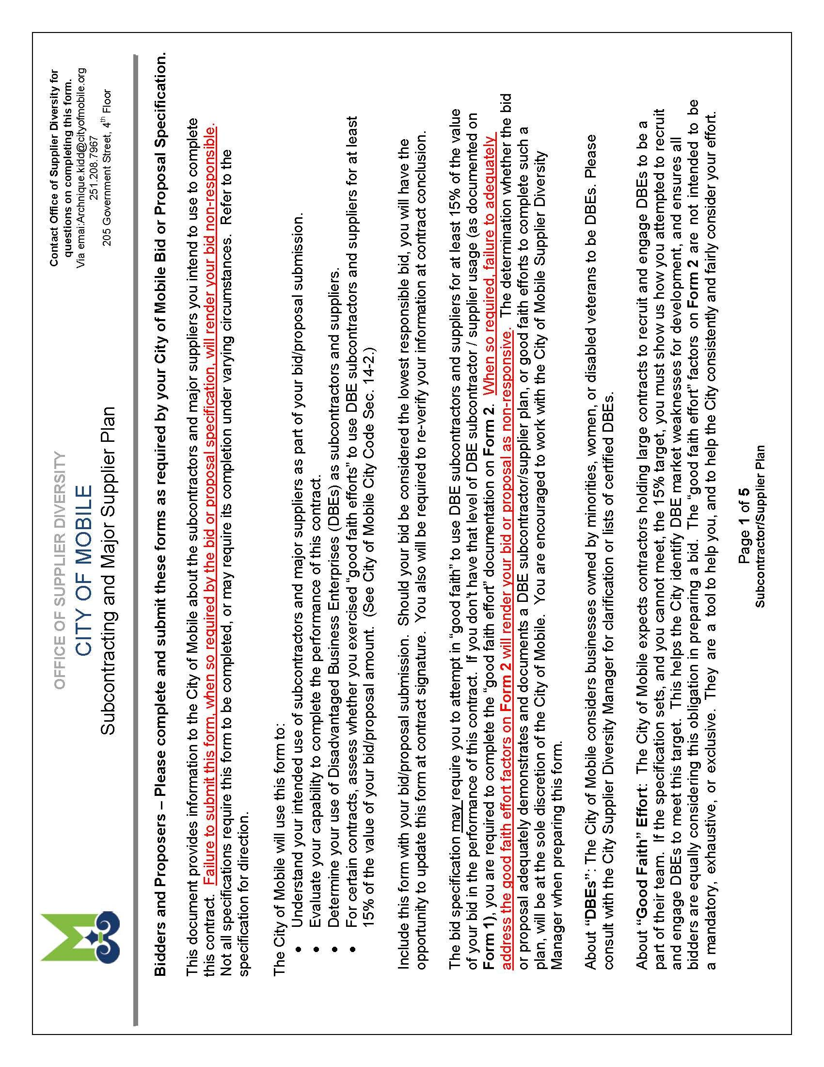

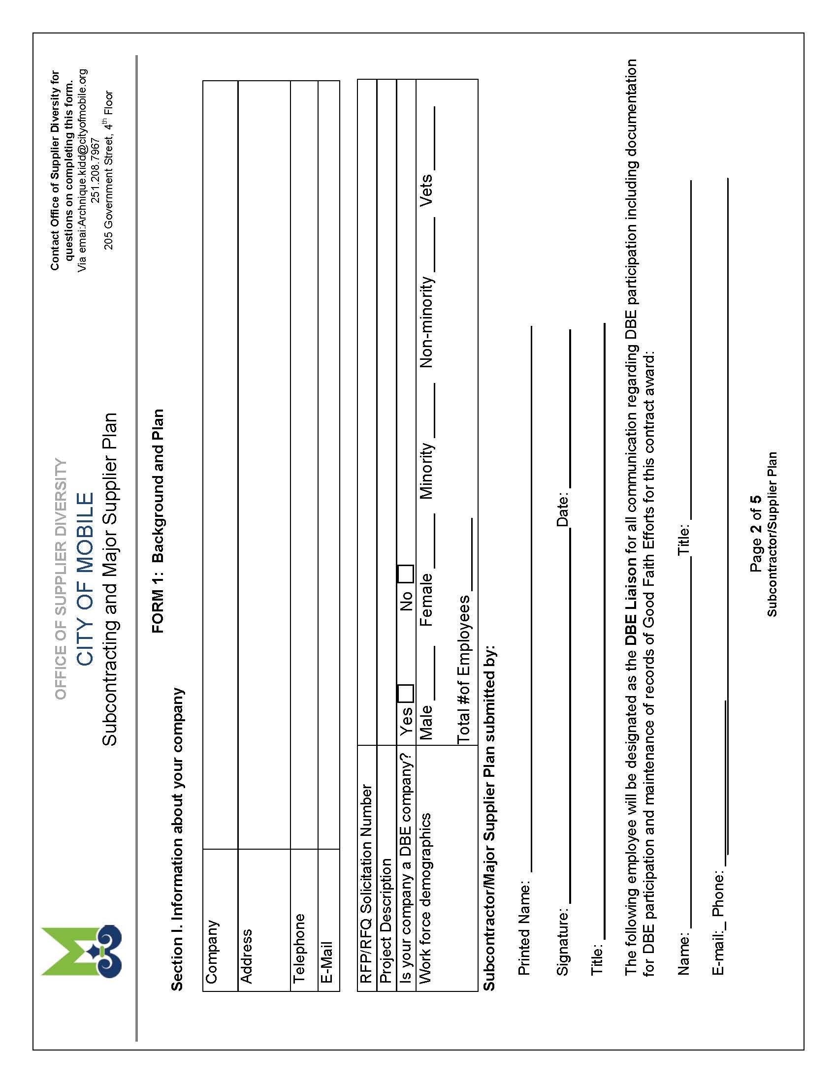

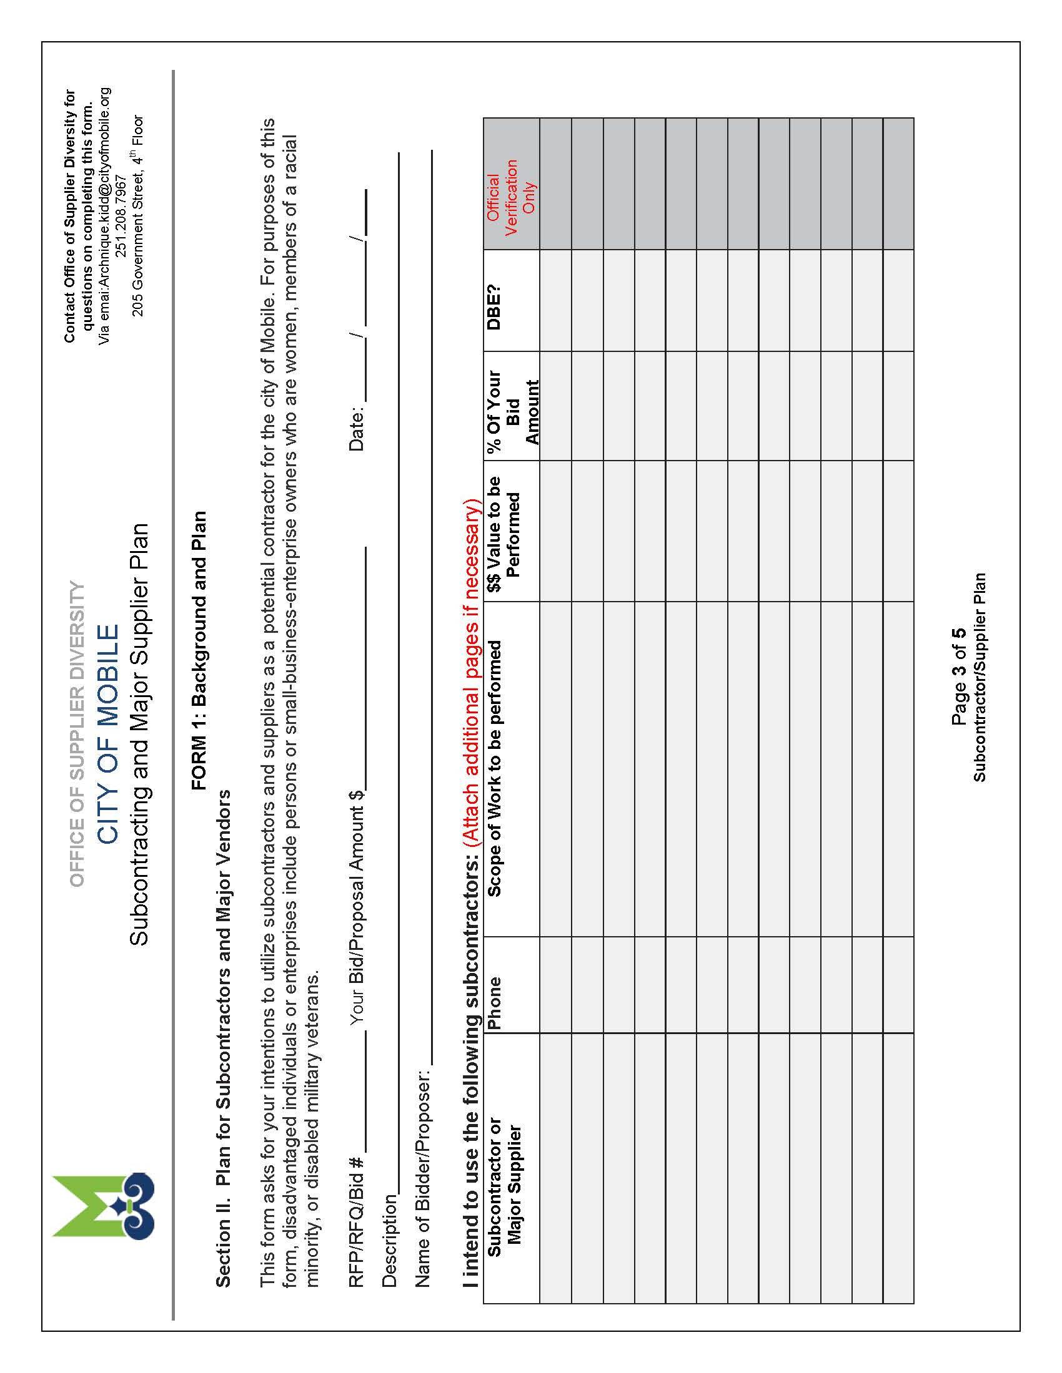

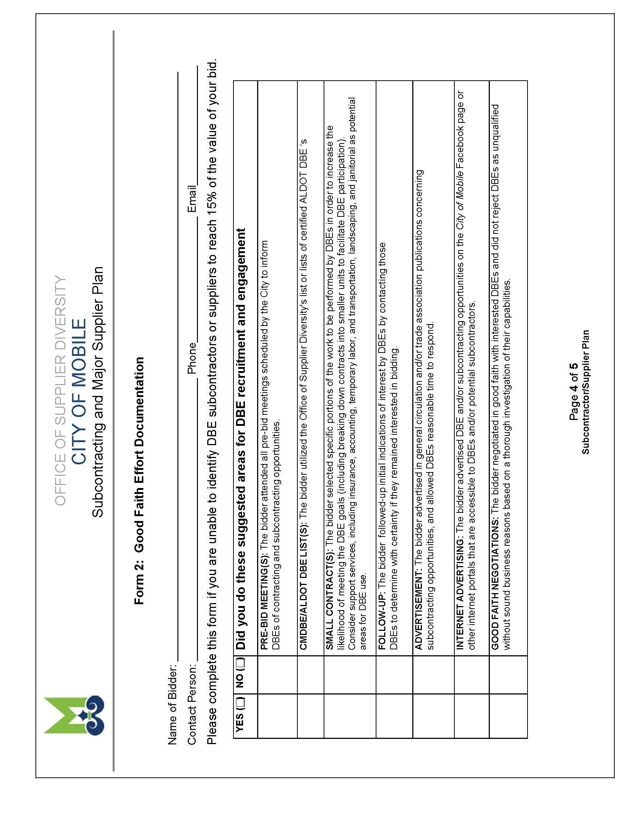

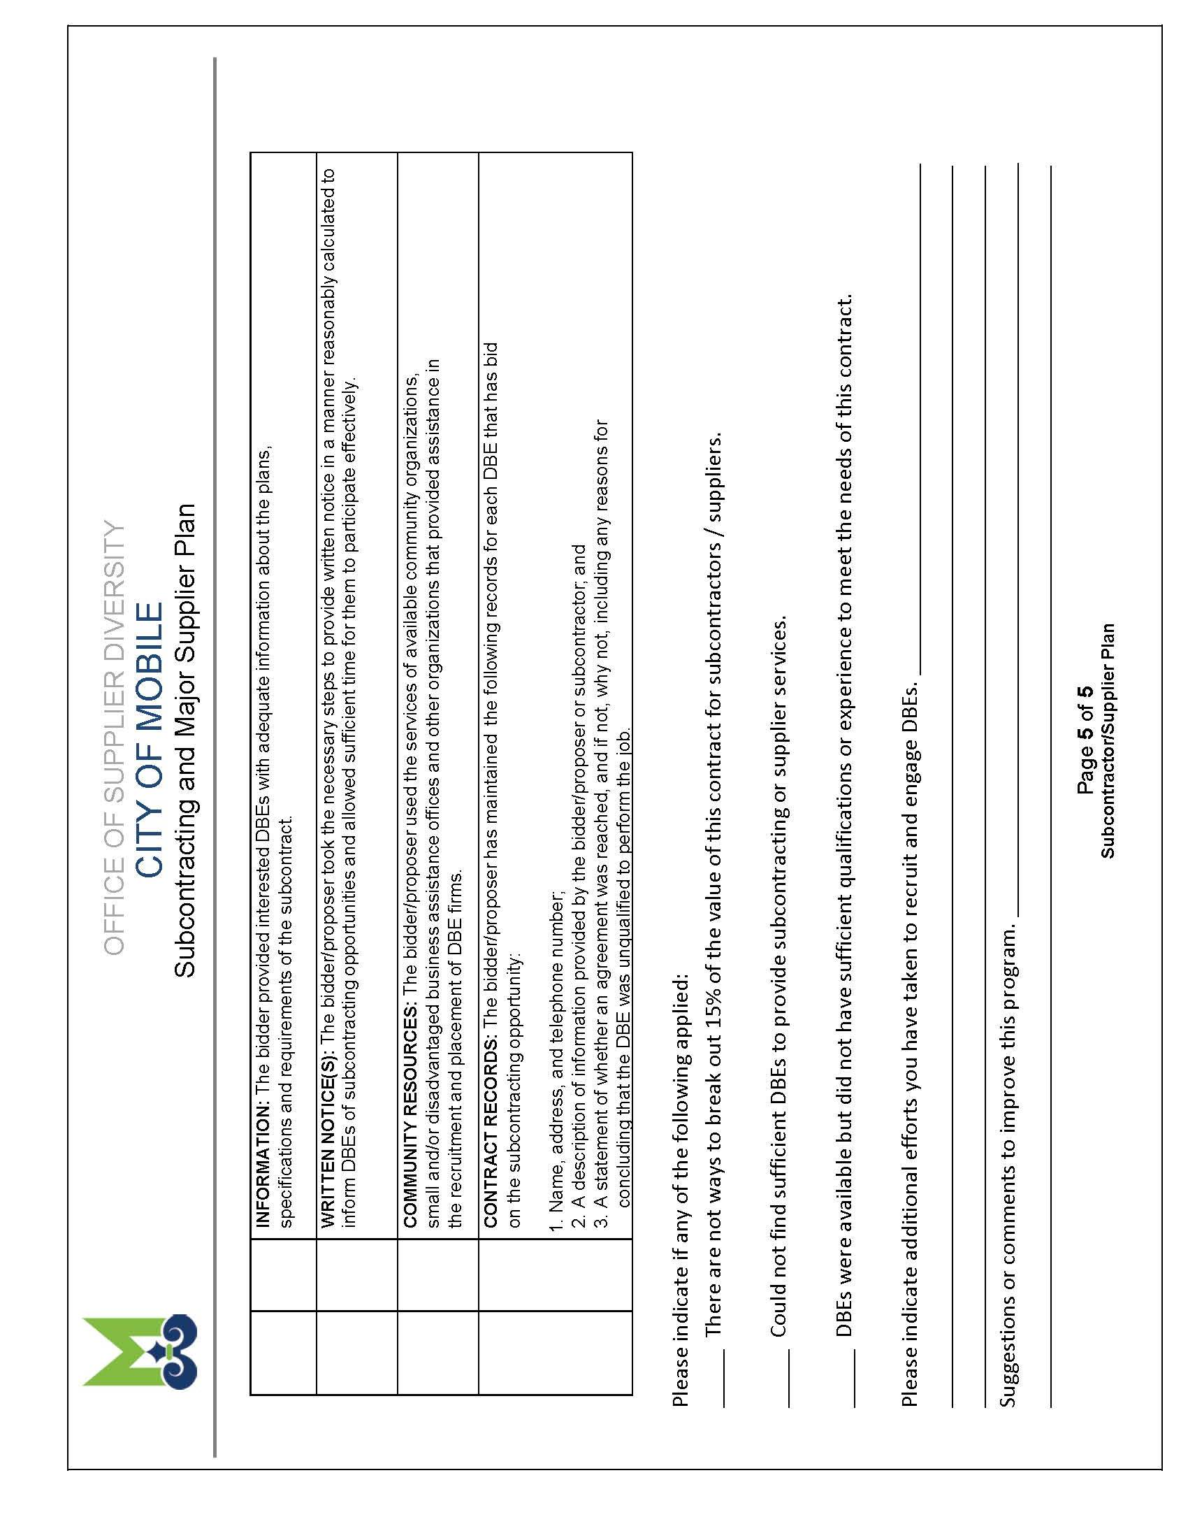

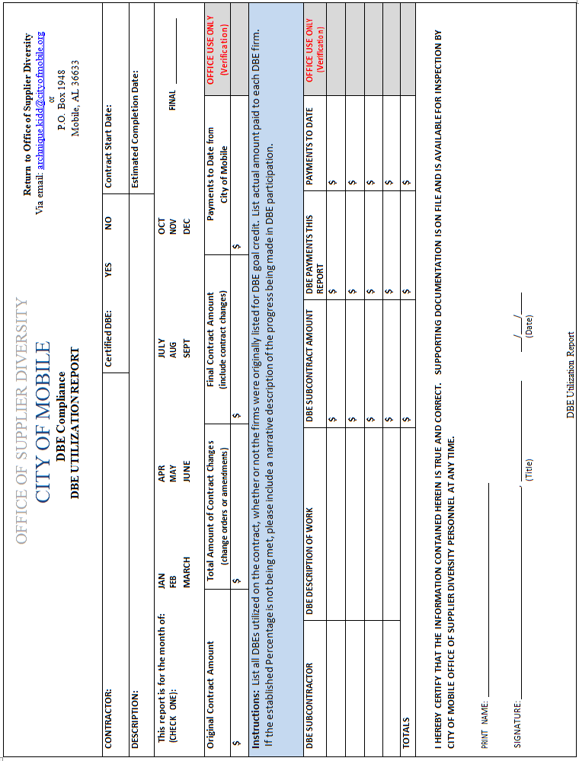

ATTACHMENT D

E-VERIFY AFFIDAVIT

STATE OF ALABAMA
COUNTY OF MOBILE

AFFIDAVIT OF VENDOR / CONTRACTOR

Before me, a Notary public, personally appeared (affiant) who, being duly sworn says as follows:
President/CEO of

As a condition for the award of a contract by the City of Mobile to a business entity or employer that employs one or more employees, I hereby attest that in my capacity as for that said employer shall not knowingly employ, hire for employment, or continue to employ an unauthorized alien.
By signing this contract, the contracting parties affirm, for the duration of the agreement, that they will not violate Federal Immigration Law or knowingly employ, hire for employment, or continue to employ an unauthorized alien within the State of Alabama. Furthermore, a contracting party found to be in violation of this provision shall be deemed in breach of the agreement and shall be responsible for all damages resulting therefrom.

I further attest that said is enrolled in the E-Verify program. The Company ID Number in the E-Verify program is as follows: .

CEO of

Sworn to and subscribed before me this the day of , 20___.
I certify that the affiant is known to me to be the identical party he or she claims to be.

Signature and Seal of Notary Public

ATTACHMENT E

CERTIFICATIONS, AFFIDAVITS
& PROJECT CLOSEOUT

CONSENT OF SURETY COMPANY

TO FINAL PAYMENT

STATE OF: | ALABAMA |  | COUNTY OF: | MOBILE

CITY OF MOBILE
CITY PROJECT NO.: 2018-2060-09
PROJECT NAME: Traffic Control Striping, Markings, and Legends Application

OWNER: CITY OF MOBILE, ALABAMA

CONTRACTOR: SURETY:

In accordance with the provisions of the Contract between the Owner and the Contractor listed above,

the Surety Company,

on bond of Contractor,

hereby approved the final payment to the Contractor, and agrees that the final payment to the Contractor shall not relieve the Surety Company of any of its obligations to Owner.

IN WITNESS WHEREOF, the Surety Company has hereinto set its hand and seal this the

day of , 20___.

Surety Company

Witness Signature of Authorized Agent

Title

CONTRACTOR’S AFFIDAVIT OF

PAYMENT OF CLAIMS & DEBTS

CITY OF MOBILE
CITY PROJECT NO.: 2018-2060-09
PROJECT NAME: Application of Thermoplastic Striping, Markings and Legends on various City of Mobile Roadways

OWNER: CITY OF MOBILE, ALABAMA

CONTRACTOR:

STATE OF: |  |  | COUNTY OF:

The undersigned hereby certifies that, except as listed below, he has paid in full or otherwise satisfied all obligations for all materials and equipment furnished, for all work, labor and services performed, and for all known indebtedness and claims against the Contractor for damages arising in any manner in connection with the performance of the contract referenced above for which the owner or his property might in any way be held responsible.

EXCETION: (If none, write none)

Contractor:

Subscribed and sworn to before me this

____ day of , 20___ By:

Title:
Notary Public:

My Commission Expires:
CITY OF MOBILE
CONTRACTOR’S CLOSEOUT REQUIREMENTS

The Contractor shall execute the following requirements as follows:

- The Contractor must publicly advertise the NOTICE OF COMPLETION furnished by City a minimum of once a week for four (4) consecutive weeks.

- The Contractor must execute copies of CONTRACTOR’S AFFIDAVIT OF PAYMENT OF CLAIMS AND DEBTS on the form furnished by the City.

- The contractor must have his surety execute copies of CONSENT OF SURETY TO FINAL PAYMENT on the form furnished by the City.

- The Contractor must furnish a letter on his letterhead acknowledging that acceptance of final payment by the Contractor constitutes a waiver of all claims, present or future, in connection with this project.

- The Contractor must furnish a written guarantee on his letterhead covering all defects in material and workmanship for a period of one (1) year commencing on the date of final acceptance.

- The Contractor must provide a report summarizing the DBE participation to include name of DBE firm, address, telephone number, and amount paid.

All the above requirements must be satisfied by the Contractor before final payment can be made.

ATTACHMENT F

PROJECT ADDENDUMS

